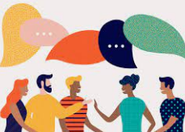
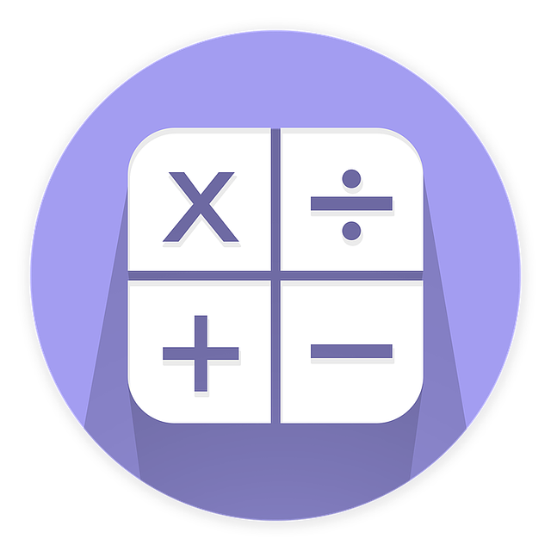
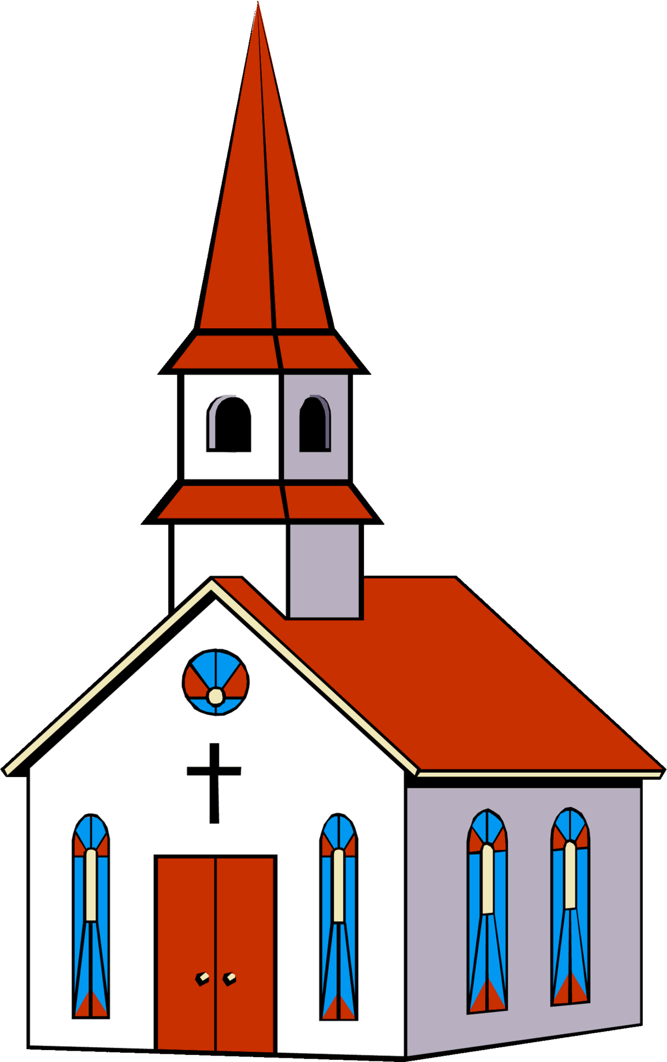
To develop me as a mathematician we will…

- Compare numbers to 5.
- Compare mass (heavier, lighter)
- Compare capacity (full, empty, half empty).
- Measure ingredients.
- Sort 6, 7 and 8.
- Add and take away (1 more, 1 less).
- Combine two numbers.
- Compare height and length (taller, shorter, longer
smaller).

To help me on my faith journey we will…

- Know about celebrations.
- Understand why we grow up.
- Discover elements of celebrations. (Chinese New Year).
- Know God created us to love others.
- Know about the parish family.
To enable me to be a strong communicator we will…

- Listen and recite the story ‘The Runaway Pancake’.
- Describe characters.
- Reread books to build up their confidence in word reading, their fluency and their understanding and enjoyment.
- Use writing to communicate thoughts, ideas, experiences and events.

This half term Reception will be learning all about…
Long Ago

To allow me to grow as a computer scientist we will…

- Use age-appropriate software to create images and record sounds and videos.
- Learn how to use the class learn pads.
- Learn how to save to the cloud.
- Learn how to close apps down.

To develop me into a knowledgeable scientist we will…

- Talk about members of their immediate family and community.
- Name and describe people who are familiar to them.
- Understand how they have changed over time
- Describe simply how weather changes as the seasons change.
- Name and sort everyday items into groups of the same material.

As a part of my home learning we will….

- Talk about what I have been learning in school.
- Read every night.
- Complete weekly tasks.
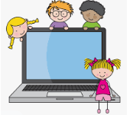
To allow me to flourish as a person we will…

- Build constructive and respectful relationships and talk about the special people in their lives and why they are important.
- Form positive attachments to adults and friendships with peers.
- Play cooperatively with others and take turns.

To allow me to grow as a musician we will….

- Access Charanga software at home together and complete an activity.
- Listen to music and responding to music through dancing or other movement.
- Enjoy listening to the music and responding to different speeds through dancing or other.
- Find the pulse naturally

To develop fine motor skills, we will…

- Practice dough disco (YouTube videos at home)
- Practice threading string, shoelaces, fastening coats, getting dressed.
- Use tweezers to transfer objects from different containers.

To help me with phonics we will…

- Practice identifying initial sounds of words (Phase 3).
- Access phonics play and teach your monster to read.
- Listen to Jolly Phonics songs on YouTube.
- Practice blending sounds together.
- Decode sentences.
- Learn to spell tricky words.

To enable me to be a confident artist we will….

- Make a peg doll.
- Create portraits of each other.
- Create buildings using physical resources.
- Create carriages using construction kits.

To enable me to thrive as a sportsperson we will...

- To move freely and with pleasure and confidence in a range of
- ways, such as slithering, shuffling, rolling, crawling, walking,
- running, jumping, skipping, sliding and hopping.
- To mount stairs, steps or climbing equipment using alternate feet.
- To run skillfully and negotiate space successfully, adjusting speed or direction to avoid obstacles.

To show me how to be a healthy citizen we will…
- Sort food groups into healthy and unhealthy.
- Pick litter up from the floor.



