

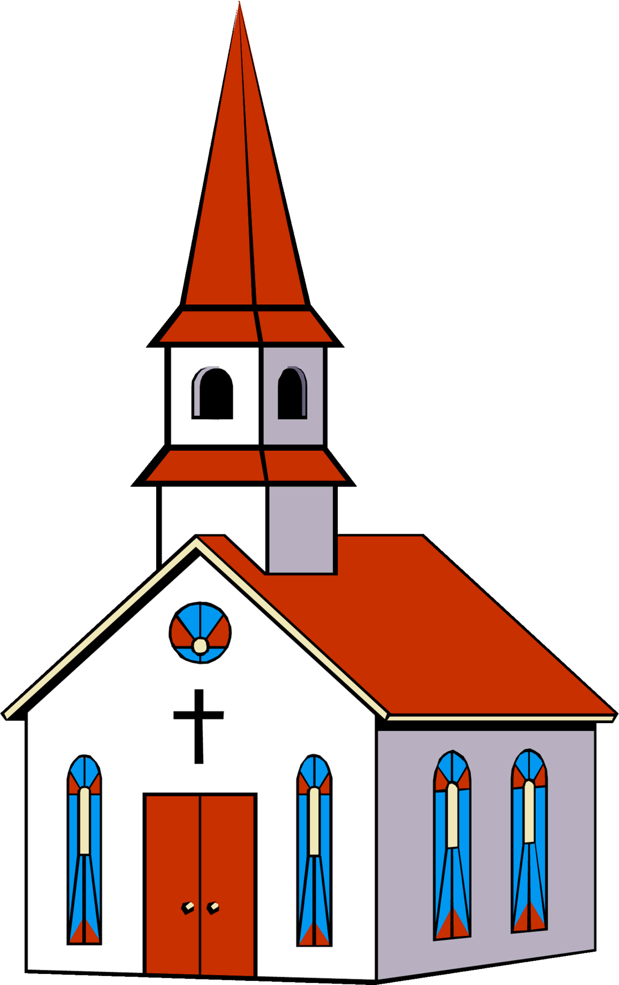
To develop me as a mathematician we will…

- Explore and represent patterns within numbers up to 10, including
evens and odds, double facts and how quantities can be distributed
equally.
- Measure and compare size, height and time.
- Make simple estimations.
- Name 2D and 3D Shapes.
- Automatically recall (without reference to rhymes, counting or other
(aids) number bonds up to 5 (including subtraction facts) and some
number bonds to 10, including double facts.

To help me on my faith journey we will…

- Know about celebrations.
- Understand why we grow up.
- Discover elements of celebrations. (Chinese New Year).
- Know God created us to love others.
- Know about the parish family.
To enable me to be a strong communicator we will…

- Listen and recite the story ‘We’re Going on a Bear Hunt’.
- Describe characters.
- Anticipate (where appropriate) key events in stories.
- Demonstrate understanding of what has been read to them by retelling stories and narratives using their own words and recently introduced vocabulary.
- Read aloud simple sentences and books that are consistent with their phonic knowledge, including some common exception words.
- Say a sound for each letter in the alphabet and at least 10 digraphs.
- Write recognisable letters, most of which are correctly formed.
- Write information (Bear fact file)
- Retell a recount (zoo trip)

This half term Reception will be learning all about…
Animal Safari

To allow me to grow as a computer scientist we will…

- Create simple programs.
- Input simple instructions to technological toys, including floor robots and onscreen sprites.
- Use technology to record their work and ideas.
- Navigate to find digital content, in digital folders and online, with supervision.
- Play learnpad Animal Apps.
- Know errors in instructions can be checked and fixed.

To develop me into a knowledgeable scientist we will…

- Features for different groups of animals, including wild and domestic animals.
- Know about vets.
- Learn about types of animals
- Visit and compare animals at Blackpool Zoo.
- Know about deferent habitats
- Match animals to their habitats
- Know about different animals and the habitats they live in.
- Comparing animals
- Know about African animals
- Sort animals according to where they live caring for pets

As a part of my home learning we will….

- Talk about what I have been learning in school.
- Read every night.
- Complete weekly tasks.

To enable design and be a confident artist we will…. (DT/ART)

- Cut, tear, fold and stick a range of papers and fabrics.
- Manipulate malleable materials into a variety of shapes and forms using their hands and other simple tools
- Make simple prints using a variety of tools, including print blocks and rollers.
- Discuss similarities and differences in their own and others' work, linked to visual elements, such as colour, scale, subject matter, composition and type. (animal patterns)
- Draw like a Scientist
- Different types of line include thick, thin, straight, zigzag, curvy and dotty.
- Create animal illustrations
- Make observations drawings
- Draw or paint a place from observation or imagination.
- Create art in different ways on
a theme, to express their ideas
and feelings.

To allow me to flourish as a person we will…

- Build constructive and respectful relationships and talk about the special people in their lives and why they are important.
- Form positive attachments to adults and friendships with peers.
- Play cooperatively with others and take turns.

To allow me to grow as a musician we will….

- Access Charanga software at home together and complete an activity.
- Listen to music and responding to music through dancing or other movement.
- Enjoy listening to the music and responding to different speeds through dancing or other.
- Find the pulse naturally

To develop gross and fine motor skills, we will…
- Negotiate space and obstacles safely, with consideration for themselves and others
- Demonstrate strength, balance and coordination when playing.
- Move energetically, such as running, jumping, dancing, hopping, skipping and climbing.
- Hold a pencil effectively in preparation for fluent writing – using the tripod grip in almost all cases.
- Use a range of small tools, including scissors, paint brushes and cutler.
- Begin to show accuracy and care when drawing.

To help me with phonics we will…

- Practice identifying initial sounds of words (Phase 3).
- Access phonics play and teach your monster to read.
- Listen to Jolly Phonics songs on YouTube.
- Practice blending sounds together.
- Decode sentences.
- Learn to spell tricky words.

To enable to understand the world we will… (History, Geography)
- Talk about the lives of the people around them and their roles in society.
- Discuss the different occupations that familiar adults and members of their community have.
- Know about vets.
- Discuss zoos of the past
- Learn about animal assistance dog and Arlo.
- Describe their immediate environment using knowledge from observation, discussion, stories, non-fiction texts and maps.
- Know some similarities and differences between different religious and cultural communities in this country, drawing on their experiences and what has been read in class.
- Explain some similarities and differences between life in this country and life in other countries, drawing on knowledge from stories, non-fiction texts and – when appropriate – maps.

To show me how to be a healthy citizen we will…
- Sort food groups into healthy and unhealthy.
- Pick litter up from the floor.



