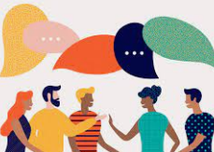

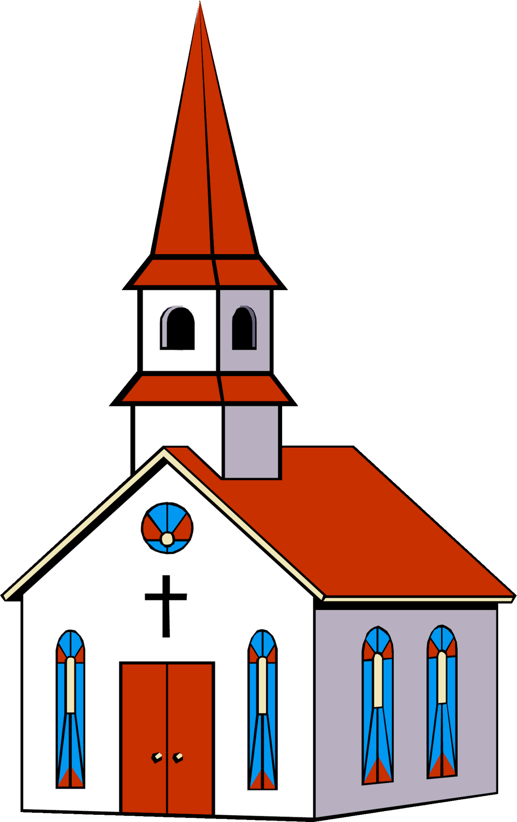
To develop me as a mathematician we will…

- Count reliably to 20 (forwards and backwards)
- Count in 2’s, 5’s and 10’s
- To add and subtract two single digit numbers by counting on or back
- Solving simple problems

To help me on my faith journey we will…

- Understand reconciliation.
- Understand who are your friends?
- Know we were created to Live in Community

To enable me to be a strong communicator we will…

- Retell the story ‘The Very Hungry Caterpillar’.
- Use and understand recently introduced vocabulary during discussions about stories, non-fiction, rhymes and poems and during role-play.
- Read aloud simple sentences and books that are consistent with their phonic knowledge, including some common exception words.
- Write recognisable letters, most of which are correctly formed.
- Spell words by identifying sounds in them and representing the sounds with a letter or letters.
- Write simple phrases and sentences that can be read by others.

This half term Reception will be learning all about…
Ready, Steady, Grow

To allow me to grow as a computer scientist we will…

- Create simple programs.
- Input simple instructions to make technological toys operate, including floor robots and onscreen sprites.
- Use technology to record their work and ideas.
- Use age-appropriate software independently.
- Know about mobile devices

To develop me into a knowledgeable scientist we will…

- Make observations about the world around them.
- Name plants they find in the school grounds
- Identify plants
- Grow plants
- Look after a plan
- Label a plant
- Draw a plant
- Know about minibeasts in the school grounds
- Observe using a magnifying glass.
- Learn about contrasting environment
- Identify similarities and differences between the
plants and animals they find in the surrounding natural environment and the contrasting one they visit (Woodend Farm)
- Experiment with teeth/germs.

As a part of my home learning we will….

- Talk about what I have been learning in school.
- Read every night.
- Complete weekly tasks.

To enable design and be a confident artist we will…. (DT/ART)

- Explore colour and application of paint using a range of different tools. (fruit art)
- Manipulate malleable materials into a variety of shapes and forms using their hands and other simple tools. (milk paint).
- create art in different ways on a theme, to express their ideas and feelings. (thread and weave). Use primary and other coloured paint and a range of methods of application.
- Select appropriate tools and media to draw with. (animals and their babies).
- Explore artwork by famous artists and talk about their likes and dislikes. (The Fruit Basket picture card by Giuseppe Arcimboldo).

To allow me to flourish as a person we will…

- Build constructive and respectful relationships and talk about the special people in their lives and why they are important.
- Form positive attachments to adults and friendships with peers.
- Play cooperatively with others and take turns.

To allow me to grow as a musician we will….

- Access Charanga software at home together and complete an activity.
- Listen to music and responding to music through dancing or other movement.
- Enjoy listening to the music and responding to different speeds through dancing or other.
- Find the pulse naturally
- Perform songs, rhymes, poems and stories with others, and – when appropriate – try to move in time with music.
- Learn some farm songs
- Make seed shakers

To develop gross and fine motor skills, we will…

- Move energetically, such as running, jumping, dancing, hopping, skipping and climbing.
- Hold a pencil effectively in preparation for fluent writing – using the tripod grip in almost all cases.
- Use a range of small tools, including scissors, paint brushes and cutlery.
To help me with phonics we will…

- Practice identifying initial sounds of words (Phase 4).
- Access phonics play and teach your monster to read.
- Listen to Jolly Phonics songs on YouTube.
- Practice blending sounds together.
- Decode sentences.
- Learn to spell tricky words.

To enable to understand the world we will… (History, Geography)

- Know some similarities and differences between things in the past and now, drawing on their experiences and what has been read in class.
- Put familiar events in chronological order, using pictures and discussion.
- Discuss farms in the past and present.
- Describe their immediate environment using knowledge from observation, discussion, stories, non-fiction texts and maps.
- Make and use simple maps in their play to represent places and journeys, real and imagined.
- Look at photographs from around the school or of the local area.

To show me how to be a healthy citizen we will…

- Pick litter up from the floor.
- Know about oral hygiene.



