
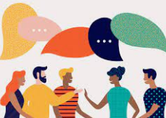
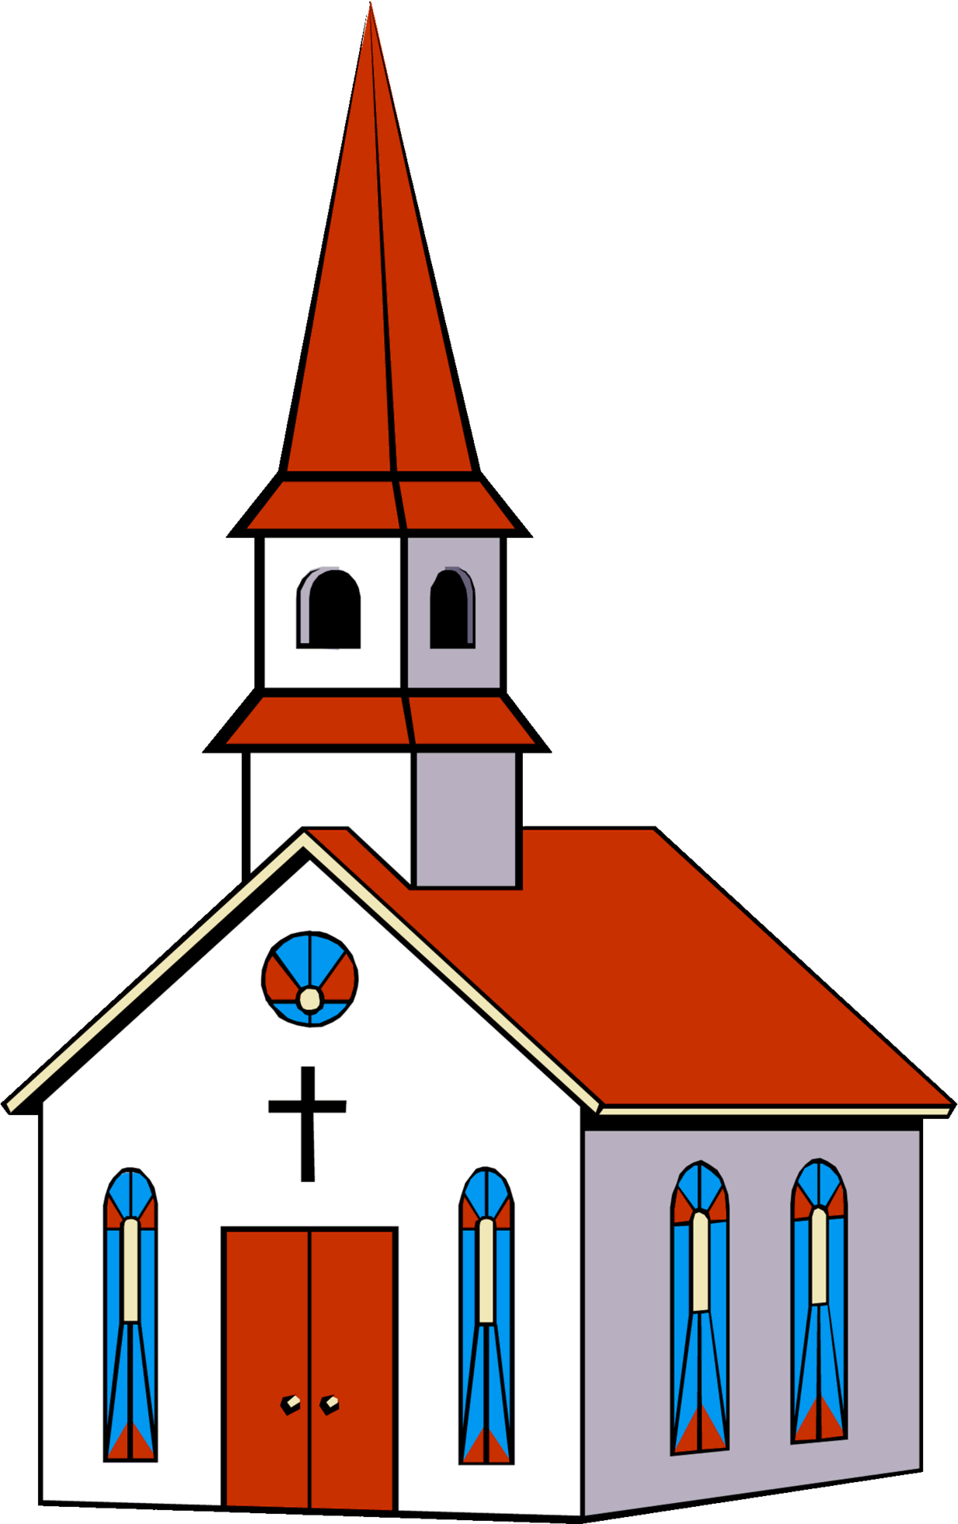
To develop me as a mathematician we will…

- Record using marks
- Measure weight, length and capacity
- Understand money
- Recognise and name 2D and 3D shapes

To help me on my faith journey we will…

- Know about the universal church.
- Understand what makes our world so wonderful,
- Know about other religions
- Understand we were Created to live in community
- Know about living in the wider world
To enable me to be a strong communicator we will…

- Retell the story ‘Goldilocks and the Three Bears’.
- Write instructions.
- Demonstrate understanding of what has been read to them by retelling stories and narratives using their own words and recently introduced vocabulary.
- Use and understand recently introduced vocabulary during discussions about stories, non-fiction, rhymes and poems and during role-play.
- Read words consistent with their phonic knowledge by sound-blending.
- Read aloud simple sentences and books that are consistent with their phonic knowledge, including some common exception words.
- Write recognisable letters, most of which are correctly formed.
- Spell words by identifying sounds in them and representing the sounds with a letter or letters.
- Write simple phrases and sentences that can be read by others.
- Enjoys looking at books and sharing stories.

This half term Reception will be learning all about…

To allow me to grow as a computer scientist we will…

- Create simple programs.
- Input simple instructions to make technological toys operate, including floor robots and onscreen sprites.
- Use technology to record their work and ideas.
- Use age-appropriate software independently.

To develop me into a knowledgeable scientist we will…

- Animals and the habitats they live in.
- Describe habitats.
- Talk about how animals are cared for when they live outside their natural habitat.
- Move like different animals.
- Know about animal diets
- Discuss objects that float and sink
- Discuss crabs, sea animals and rock pools on our beach trip.
- Features for different groups of animals, including wild and domestic animals.
- Know about living things
- Discuss clothes they wear in different seasons and why.
- Identifying objects being blown around outdoors
- Know what happens when they poured sand/water through wheels and down gutters and how they changed this.
On the Beach

As a part of my home learning we will….

- Talk about what I have been learning in school.
- Read every night.
- Complete weekly tasks.

To enable design and be a confident artist we will…. (DT/ART)
- Create art in different ways on a theme, to express their ideas and feelings. (starfish)
- Cut, tear, fold and stick a range of papers and fabrics.
- Manipulate malleable materials into a variety of shapes and forms using their hands and other simple tools. (sand molds).
- Adapt and refine their work as they are constructing and making.
- Share their creations with others, explaining their intentions and the techniques and tools they used. Construct simple structures and models using a range of materials. (boats).
- Draw or paint a place from observation or imagination. (animals in the sea).
- Explore artwork by famous artists and talk about their likes and dislikes. Paintings could include The Beach at Trouville by Claude Monet, 1870;
Beach Scene by Edgar Degas,
- 1869–70, Rhyl Sands by David Cox, 1854–5, View of Collioure (The Tower) by Henri
Matisse, 1905 or contemporary
artwork by artists like Laura Wall.

To allow me to flourish as a person we will…

- Set and work towards simple goals, being able to wait for what they want and control their immediate impulses when appropriate.
- Give focused attention to what the teacher says, responding appropriately even when engaged in activity, and show an ability to follow instructions involving several ideas or actions.
- Explain the reasons for rules, know right from wrong and try to behave accordingly.
- Play cooperatively with others and take turns.

To allow me to grow as a musician we will….

- Access Charanga software at home together and complete an activity.
- Listen to music and responding to music through dancing or other movement.
- Enjoy listening to the music and responding to different speeds through dancing or other.
- Find the pulse naturally
- Sing a range of well-known nursery rhymes and songs.
Listen to a variety of music and sounds.
- Learn some sea side songs
- Discuss sounds of the sea
To develop gross and fine motor skills, we will…

- Negotiate space and obstacles safely, with consideration for themselves and others.
- Move energetically, such as running, jumping, dancing, hopping, skipping and climbing.
- Hold a pencil effectively in preparation for fluent writing – using the tripod grip in almost all cases.
- Use a range of small tools, including scissors, paint brushes and cutlery.
- Begin to show accuracy and care when drawing.

To help me with phonics we will…

- Practice identifying initial sounds of words (Phase 4).
- Access phonics play and teach your monster to read.
- Listen to Jolly Phonics songs on YouTube.
- Practice blending sounds together.
- Decode sentences.
- Learn to spell tricky words.

To enable to understand the world we will… (History, Geography)
- Know some similarities and differences between things in the past and now, drawing on their experiences and what has been read in class.
- Talk about the lives of the people around them and their roles in society.
- Order an event using words relating to the passage of time, including yesterday, last week, before and then.
- Discuss holidays past and present
- British seashore.
- Locate the Irish Sea.
- Know geographical information can be collected by using simple tally charts and pictograms.
- Understand how to look after the immediate environment.
- Know leaving litter on beaches can potentially kill marine life.

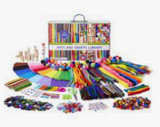
To show me how to be a healthy citizen we will…

- Manage their own basic hygiene and personal needs, including dressing, going to the toilet and understanding the importance of healthy food choices.

