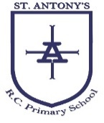
Join the faith and learning journey

READING SPINE YEAR …

TERM/SUBJECT | MARIAN | REMEMBRANCE | CANDLEMAS | LENTEN | ROSARY | TRINITY
READING FOR PLEASURE | 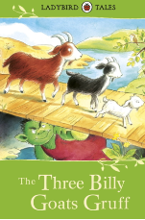  The Three Billy Goats Gruff | 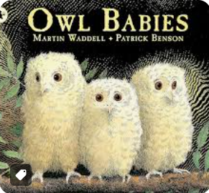  Owl babies- Martin Waddell and Patrick Benson | 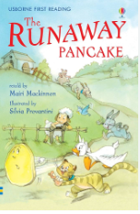  The Runaway Pancake | We’re Going on a Bear Hunt- Michal Rosen and Helen Oxenbury  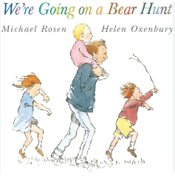 | The Very Hungry Caterpillar- Eric Carle  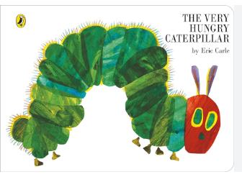 | Goldilocks and the Three Bears  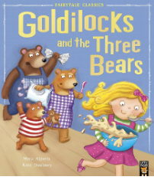
SPIRITUAL | Children’s Bible  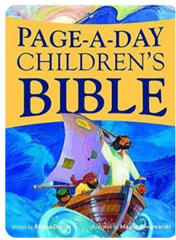 |  | God Knows My Name  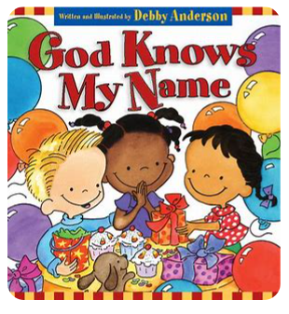 |  | 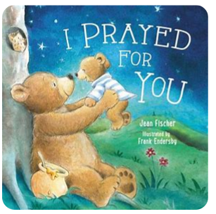  I Prayed For You
PSHE | Starting School-  Janet and Allan Ahlberg  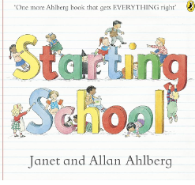 | The Color Monster- Anna Llenas  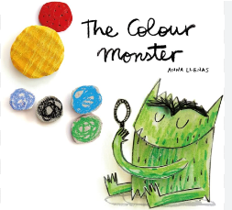 | Guess how much I love you- Sam McBratney  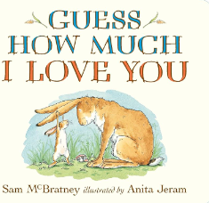 | 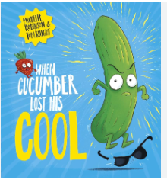  When Cucumber Lost His Cool | Find Your Happy- Emily Coxhead  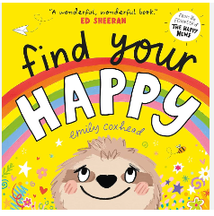 | The Way I Feel  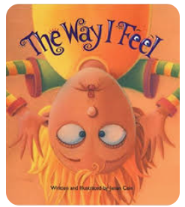
STEM | Grandpas quilt  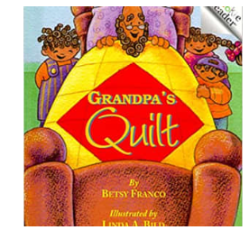 |  | 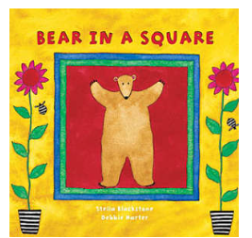  Bear in a square |  | 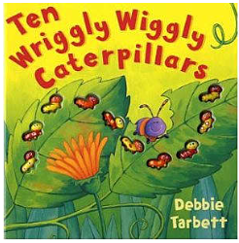  Ten Wriggly Wiggly Caterpillars
SCIENCE | Dear Zoo- Rod Campbell  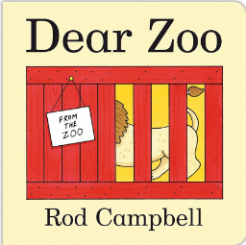 | Nature Trail – Nila Ave  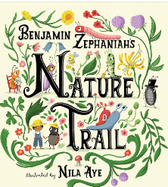 | Luna loves gardening  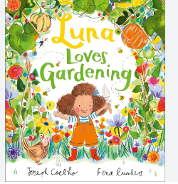 | Wise about my body  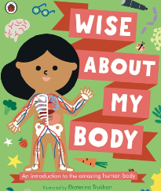 | Growing Story  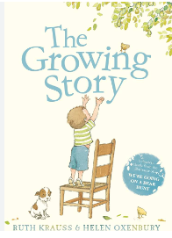 | Funny Bones  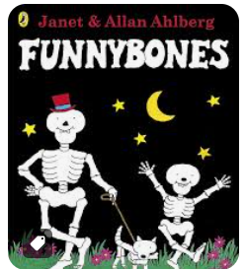
GEOGRAPHY | Where’s spot? - Eric Hill  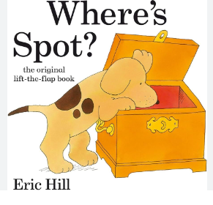 | Welcome  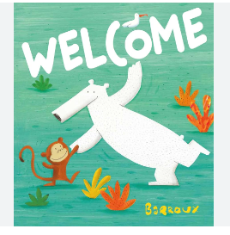 | 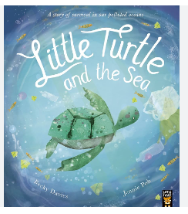  Little turtle and the sea | 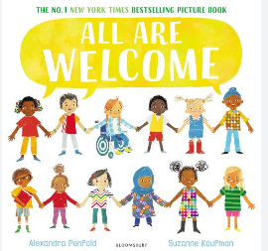  All are welcome | Handa’s surprise  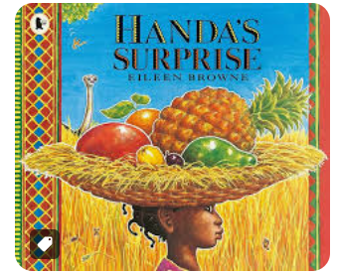 | 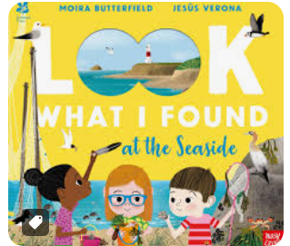  Look what I found at the sea side
HISTORY | 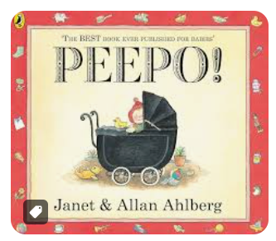  Peepo | 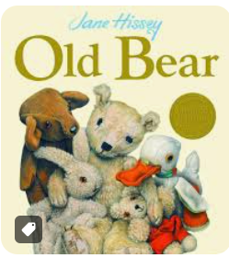  Old bear | When I was a child 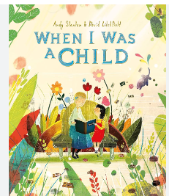 | Pumpkin Soup  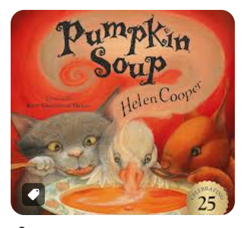 | Clothes then and now  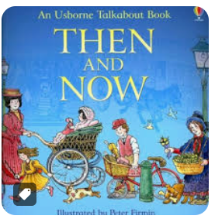 | 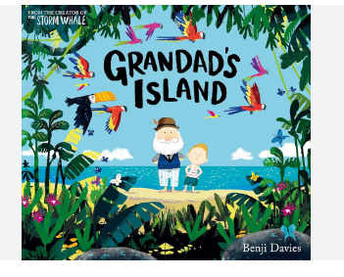  Grandads island
ART AND DESIGN | You choose- Nick Sharratt and Pippa Goodhart  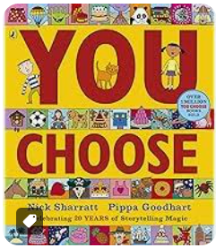 | Elmer- David McKee  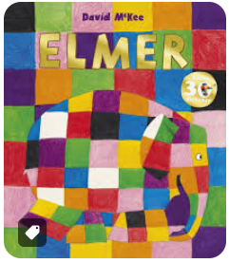 | Can I build another me?  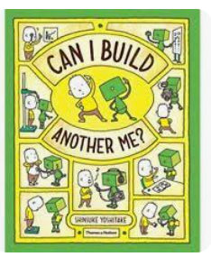 | Beautiful oops  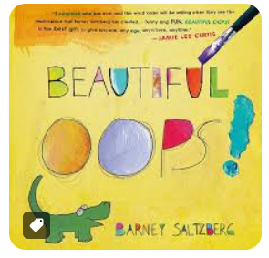 | Never let the diplodocus draw  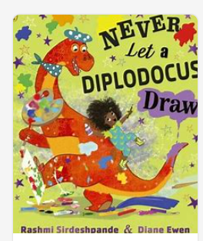 | Mixed-Arree Chung  

